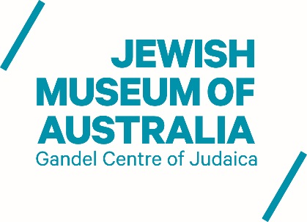

EXPRESSIONS OF INTEREST – CURATOR POST

The Jewish Museum of Australia is now receiving expressions of interest for the position of permanent part-time Curator and short term curatorial project roles.
The Curator is responsible for contributing to the development, research and interpretation of the Museum’s collection and for the coordination and delivery of the Museum’s exhibition program, under the direction of the Senior Curator & Collections Manager. Short term roles may be available for projects around exhibition, interpretation and collections management work.
The Museum seeks a candidate with Museum Studies and curatorial training in Jewish Studies or a relevant field to contribute to the development and management of general and special collections, as well as exhibitions supporting this interdisciplinary field.
Experience / Skills
- High level of research skills and knowledge of bibliographic and other information resources.
- Museum or gallery-based curatorial practice.
- Enthusiasm for delivering collections and exhibition services; a heritage context an advantage.
- A passion for museums, preserving and sharing object histories.
- Ability to engage with visitors from all backgrounds.
- Attention to detail, resourcefulness and enthusiasm.
- Experience of working in cross-disciplinary teams an advantage.
- Experience of working with volunteers an advantage.
- An appropriate qualification in Museum studies an advantage.
- Demonstrable commitment to continuing professional development.
- Excellent communication skills, both written and verbal.
- Time management and IT skills.

Expressions of interest
Candidates should forward a comprehensive CV, and a cover letter (2 pages maximum) which includes details of relevant experience, by April 13, 2018.
Candidates are encouraged to contact Eleni Papavasileiou, Senior Curator & Collection Manager with any queries or to discuss their expression of interest in advance of submission.
E: e.papavasileiou@jewishmuseum.com.au
T: (03) 8534 3617

